

Practices for Secure Software Report

Table of Contents
Document Revision History 3
Client 3
Developer 3
1. Algorithm Cipher 4
2. Certificate Generation 5
3. Deploy Cipher 5
4. Secure Communications 5
5. Secondary Testing 6
6. Functional Testing 7
7. Summary 7
8. Industry Standard Best Practices 8

Document Revision History

Version | Date | Author | Comments
1.0 | 10/15/26 | Christopher Ellison | Making it count

Client



Developer
Christopher Ellison

Algorithm Cipher
For Artemis Financial’s web application, Advanced Encryption Standard (AES) is a strong choice for protecting sensitive financial information. AES is a symmetric encryption algorithm that uses the same key to encrypt and decrypt data. It operates on 128-bit blocks and supports 128-, 192-, and 256-bit keys. AES-256 is recommended because its longer key provides strong resistance to brute-force attacks, making it suitable for protecting financial data.
AES can be combined with Galois/Counter Mode (GCM) to provide both confidentiality and integrity. GCM generates an authentication tag that helps detect unauthorized changes to encrypted data. Artemis should generate a unique initialization vector (IV) for every encryption operation using the same key, as reusing an IV can weaken security. Encryption keys should also be generated using a secure random number generator, stored separately from protected data, and made accessible only to authorized users.
Since Artemis also requires file verification during data transfers, SHA-256 is an appropriate hashing algorithm. SHA-256 produces a 256-bit hash value that can help verify whether a file has changed. Unlike encryption, hashing is one-way and does not conceal the original data. To verify a transfer, the receiving system should compare the calculated hash against a trusted hash value received through a secure, authenticated process. Otherwise, an attacker could alter both the file and its checksum. AES-GCM’s authentication tag provides an additional layer of protection against tampering with encrypted data.
Encryption standards have evolved as computing power and attack methods have improved. Older algorithms, such as DES and RC4, are no longer appropriate for new security implementations because of their vulnerabilities. AES became a widely adopted standard because it provides strong security and practical performance across different systems. For Artemis Financial, AES-256-GCM combined with SHA-256 file verification offers a practical approach to protecting financial information and detecting unauthorized changes. However, effective security also requires proper key management, access controls, secure communications, and regular monitoring.

Certificate Generation
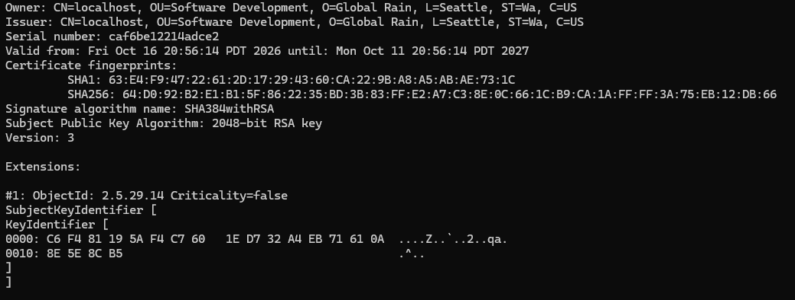

Deploy Cipher
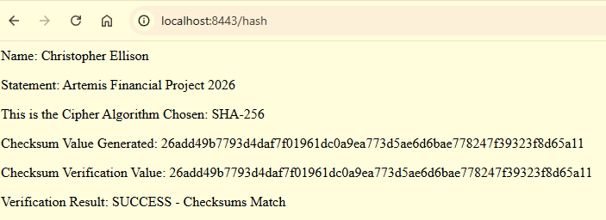

Secure Communications
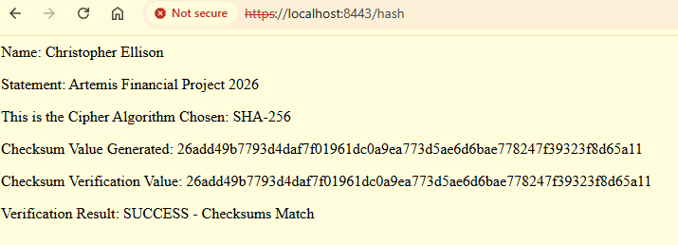

Secondary Testing
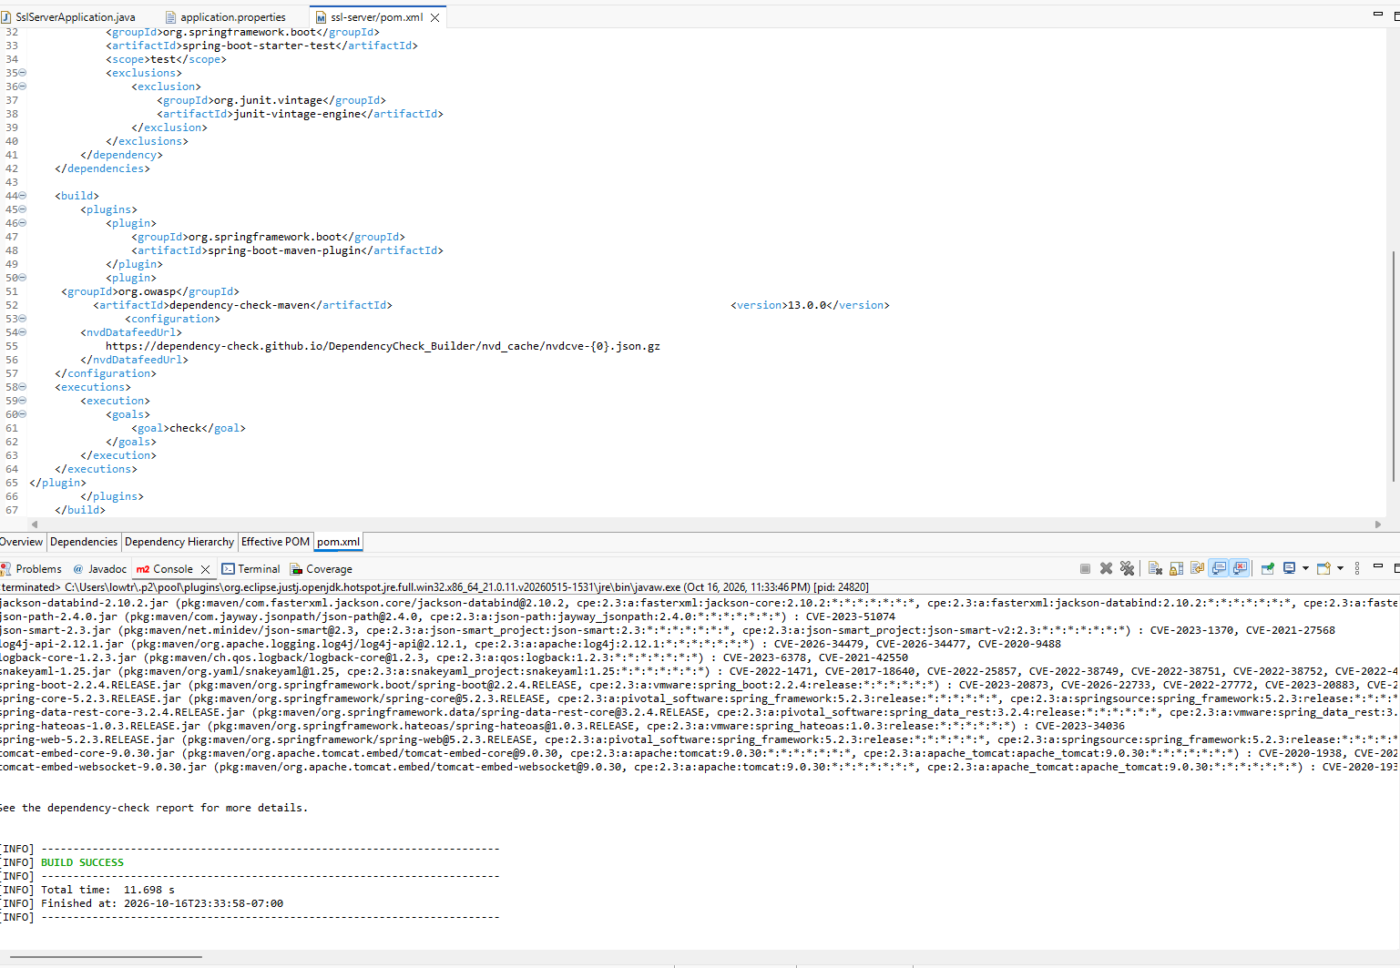
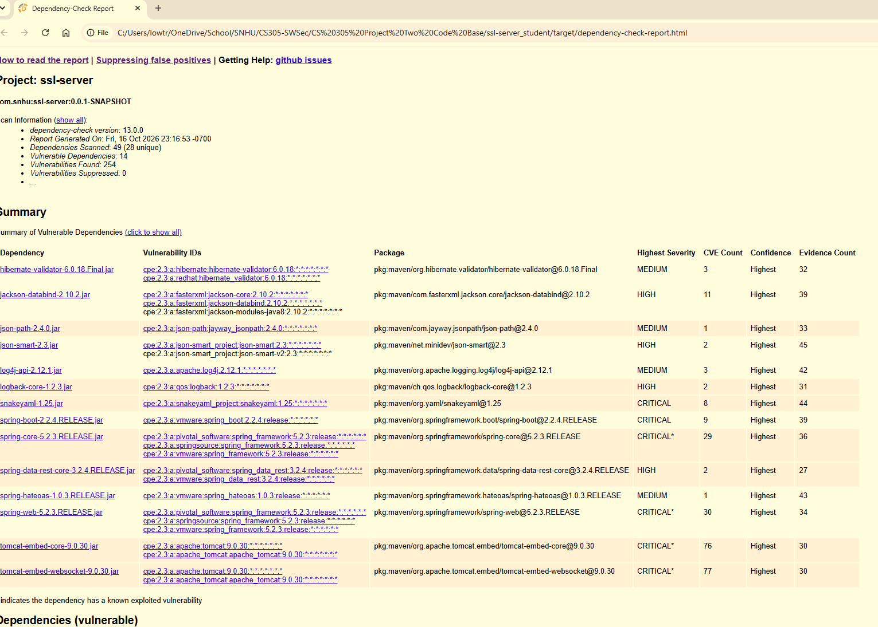

Functional Testing
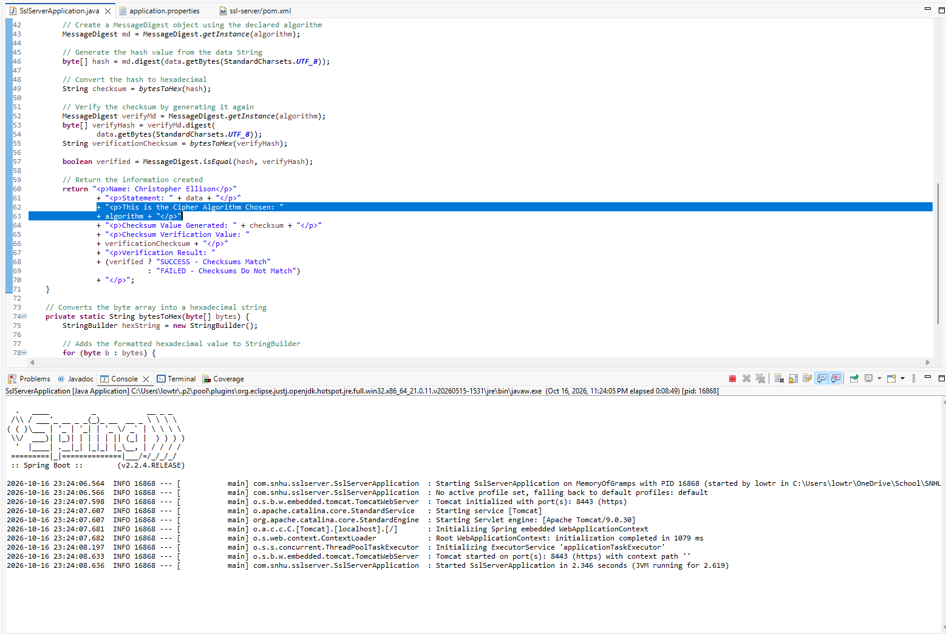

Summary
I refactored Artemis Financial’s application to improve data integrity, secure communication, and reduce security risks. Following the vulnerability assessment process, I focused on protecting data, securing connections, and checking software dependencies for known vulnerabilities.
I implemented SHA-256 hashing to generate and verify checksums, helping identify changes to data. I also configured the application to use HTTPS with a self-signed certificate, allowing data to be transmitted through an encrypted connection. I tested the application to confirm that the checksum verification worked and that the application ran successfully over HTTPS.
I used OWASP Dependency-Check to scan the application’s dependencies for known vulnerabilities. The results identified issues that will be addressed by updating affected dependencies and rerunning the scan. I also manually reviewed and tested the refactored code for syntax, logic, and security issues.
To add layers of security, I combined hashing, HTTPS, certificate configuration, dependency scanning, and functional testing. Each measure addresses different risks and helps protect the application. Additional improvements could include stronger access controls, secure key management, and regular security updates.
Overall, the refactoring improved the application’s security and helped me understand the importance of testing each change. Using multiple security measures together provides better protection for Artemis Financial’s data and helps support secure software development.

Industry Standard Best Practices
I applied industry-standard secure coding practices to improve Artemis Financial’s application and maintain its existing security. I implemented SHA-256 checksum verification to help detect data changes, configured HTTPS to protect information during transmission, and used a self-signed certificate to enable secure communication during testing. I also used OWASP Dependency-Check to identify known vulnerabilities in software dependencies and reviewed the code for potential syntax, logic, and security issues. Updating vulnerable dependencies and regularly testing the application will help maintain its security over time.
Following secure coding best practices helps Artemis Financial protect sensitive financial information, reduce the risk of data breaches, and maintain customer trust. These practices can also reduce the costs associated with security incidents and system downtime. By combining encryption, secure communication, code reviews, and regular security testing, the company can build a more reliable application and better protect its business and customers.

